**1.Introduction**

Welcome to the introduction of a University Result Management System. This system is designed to streamline and automate the process of managing and publishing the results of students enrolled in a university.

The system is built on a web-based platform that provides secure access to authorized users such as faculty members, administrative staff, and students. It offers a user-friendly interface that allows users to manage and view various aspects of student results.

The University Result Management System has a range of features that enable easy and efficient management of student results. These include the ability to input and manage student data, such as personal information and academic records, as well as the ability to generate and publish result reports.

The system also provides features for managing course registrations, grading, and exam scheduling. It enables faculty members to easily input and manage grades, and provides students with easy access to their grades and academic records.

Furthermore, the University Result Management System offers a range of customizable features, enabling universities to adapt the system to their specific needs. This includes customizing the user interface, generating reports, and setting up alerts and notifications.

Overall, the University Result Management System is an efficient, reliable, and secure way of managing and publishing student results. It is an essential tool for universities to provide timely and accurate results to their students, faculty members, and administrative staff.

**1.1 Purpose**

The purpose of a university result management system is to effectively manage and organize student academic records, including their grades and overall academic progress. This system allows universities to efficiently calculate and process student grades, generate reports and transcripts, and provide timely feedback to students about their academic performance.

Some specific benefits of a university result management system include:

1. Accuracy and consistency: With a result management system, universities can ensure the accuracy and consistency of student grades across various courses, semesters, and programs.
2. Efficiency: Automating the result management process can save time and effort for both faculty and administrative staff, allowing them to focus on other important tasks.
3. Transparency: The system can provide transparency to both students and faculty, allowing them to access and review academic records and progress reports.
4. Analysis and decision-making: With access to detailed academic data, universities can analyze trends, identify areas for improvement, and make data-driven decisions about curriculum and teaching methods.

Overall, a result management system helps universities to maintain accurate academic records, provide timely feedback to students, and improve the overall quality of education they provide.

**1.2 Scope**

* Student Management: The system should be able to manage student data including personal information, academic records, course enrollment, and results.
* Course Management: The system should be able to manage course data, including course descriptions, course schedules, and course offerings.
* Exam Management: The system should be able to manage exams, including date of exams.
* Result Management: The system should be able to manage student results, including entry of marks, grade calculations, and grade reports.
* Automated Result Generation: The system should be able to automatically generate results based on the data entered by the faculty.
* Reporting: The system should provide reporting capabilities that enable faculty and administrators to access relevant data such as student results, course enrollment, and faculty workload.
* Analytics: The system should provide analytics capabilities that enable faculty and administrators to analyze data and identify trends that can help in decision-making.
* Communication: The system should enable communication between faculty, students, and administrators regarding course registration, results, and other academic information.
* Security: The system should ensure the security of student data and prevent unauthorized access.

**2.** [**Overview of the module**](https://docs.google.com/document/d/18ozbwUCaBnUTzfUSOrGjdkbPeiqtM7Xr/edit#heading=h.184mhaj)

**2.1 Users**

1. Student
2. Teacher
   1. Chairman of Department
   2. Course teacher
   3. Examiner
   4. Invigilator
   5. Tabulator
   6. Chairman of Exam committee
   7. Exam committee Member
3. Department
   1. Staff (Nitai da)
4. Exam Controller
5. System Administrator

**2.1 use case (uml)**

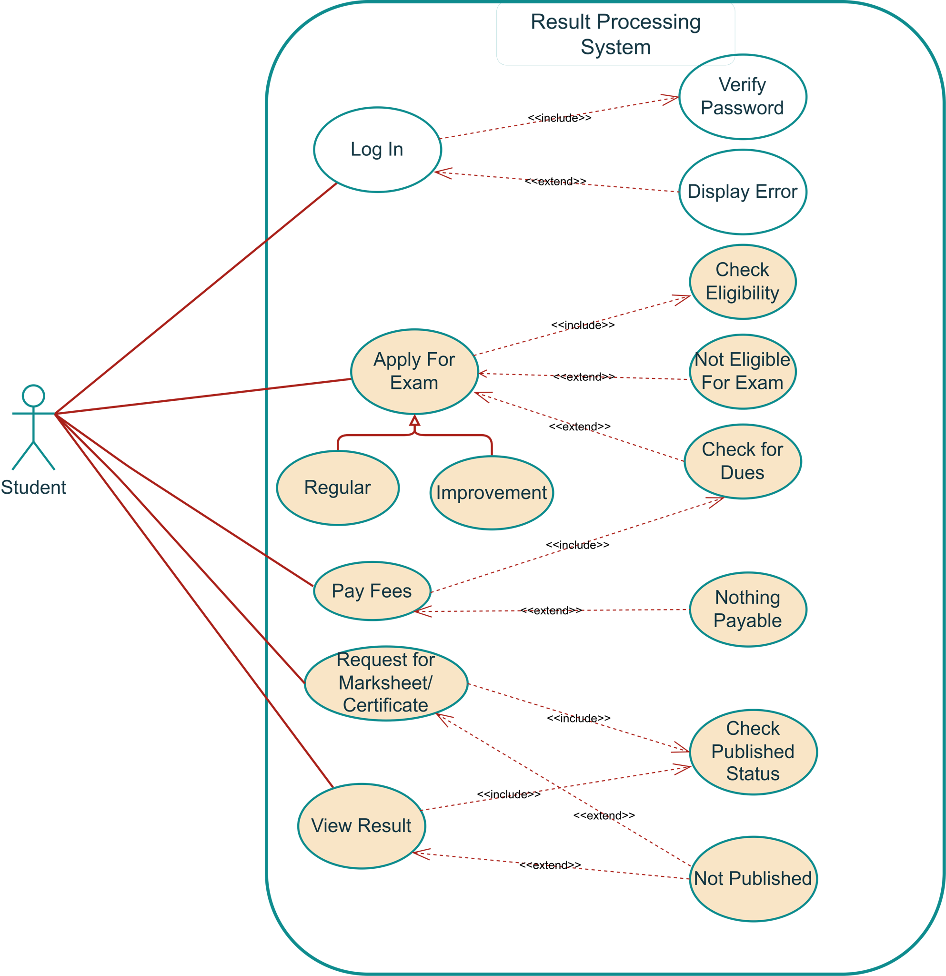

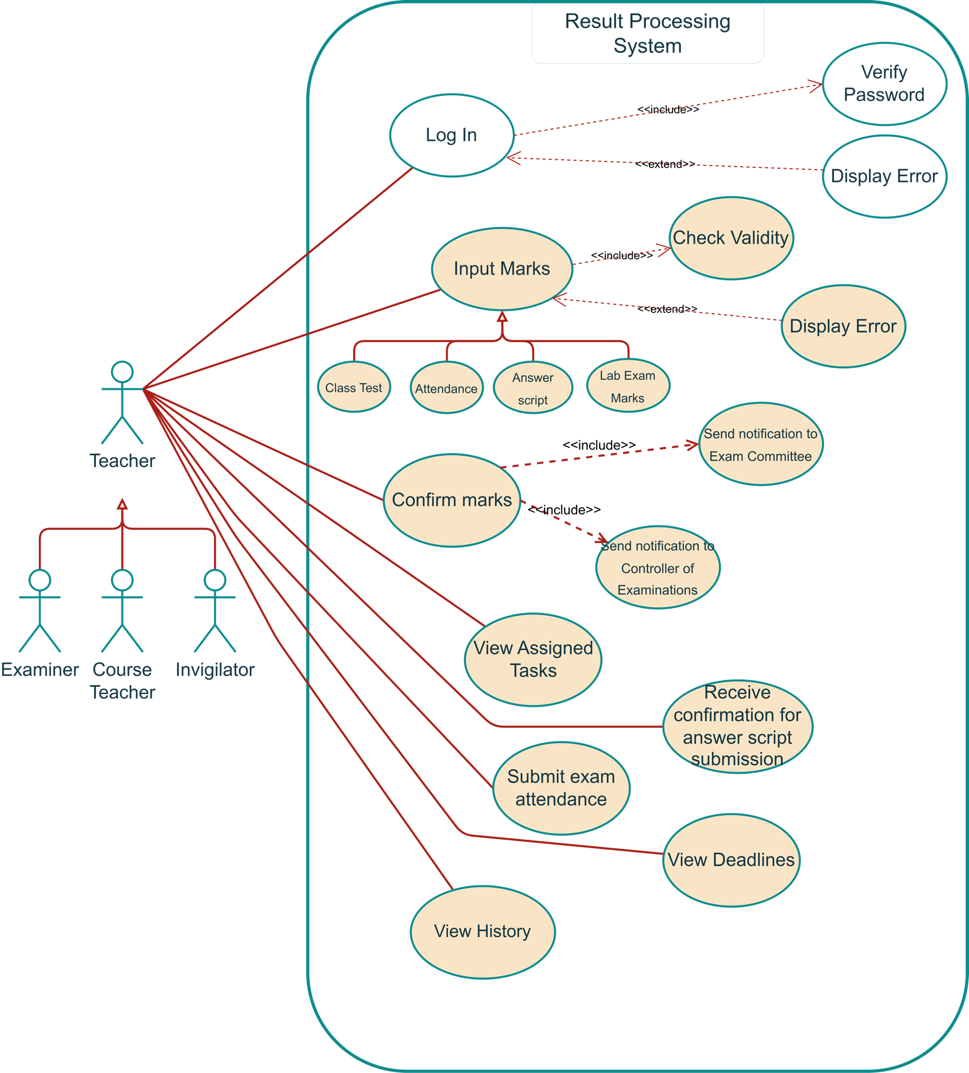

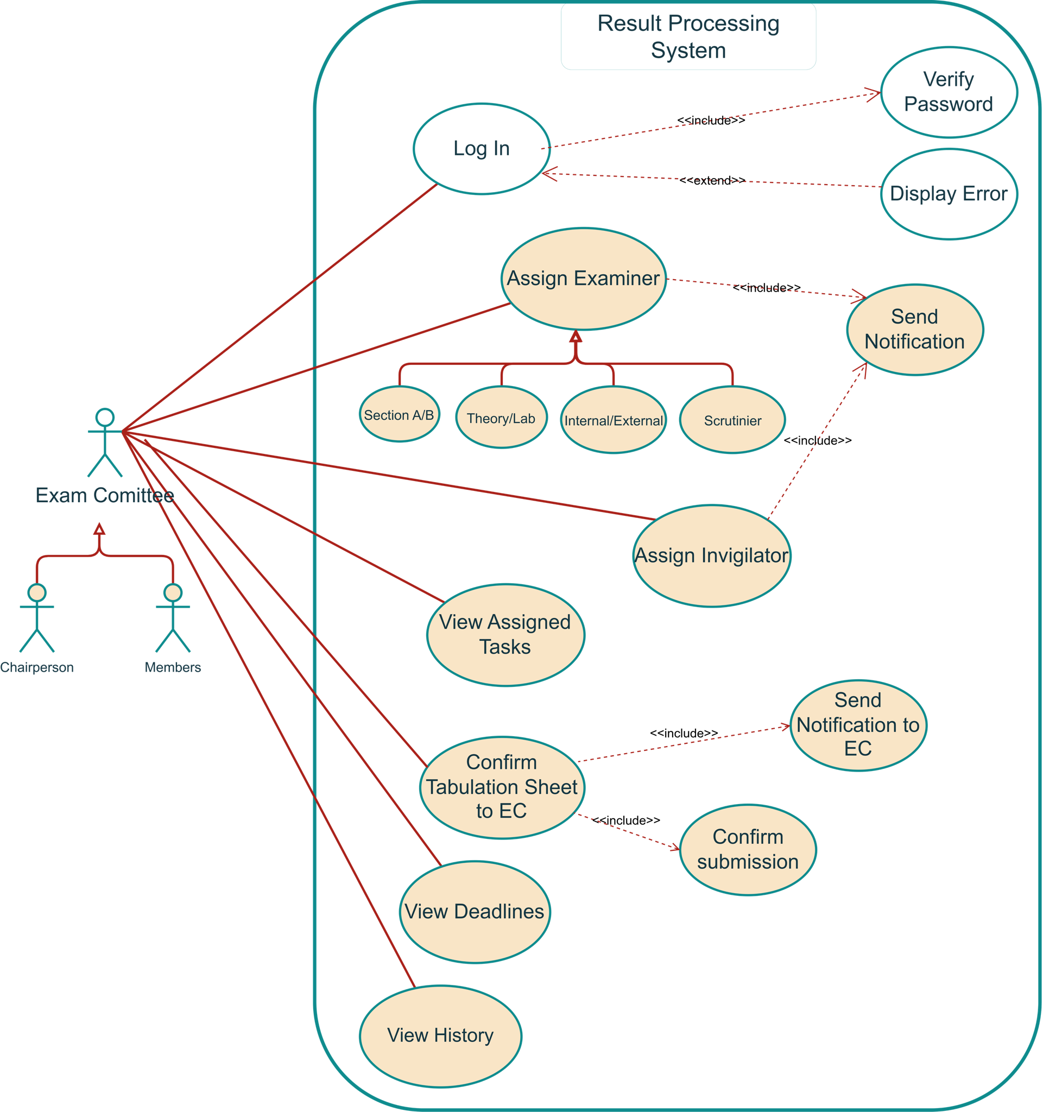

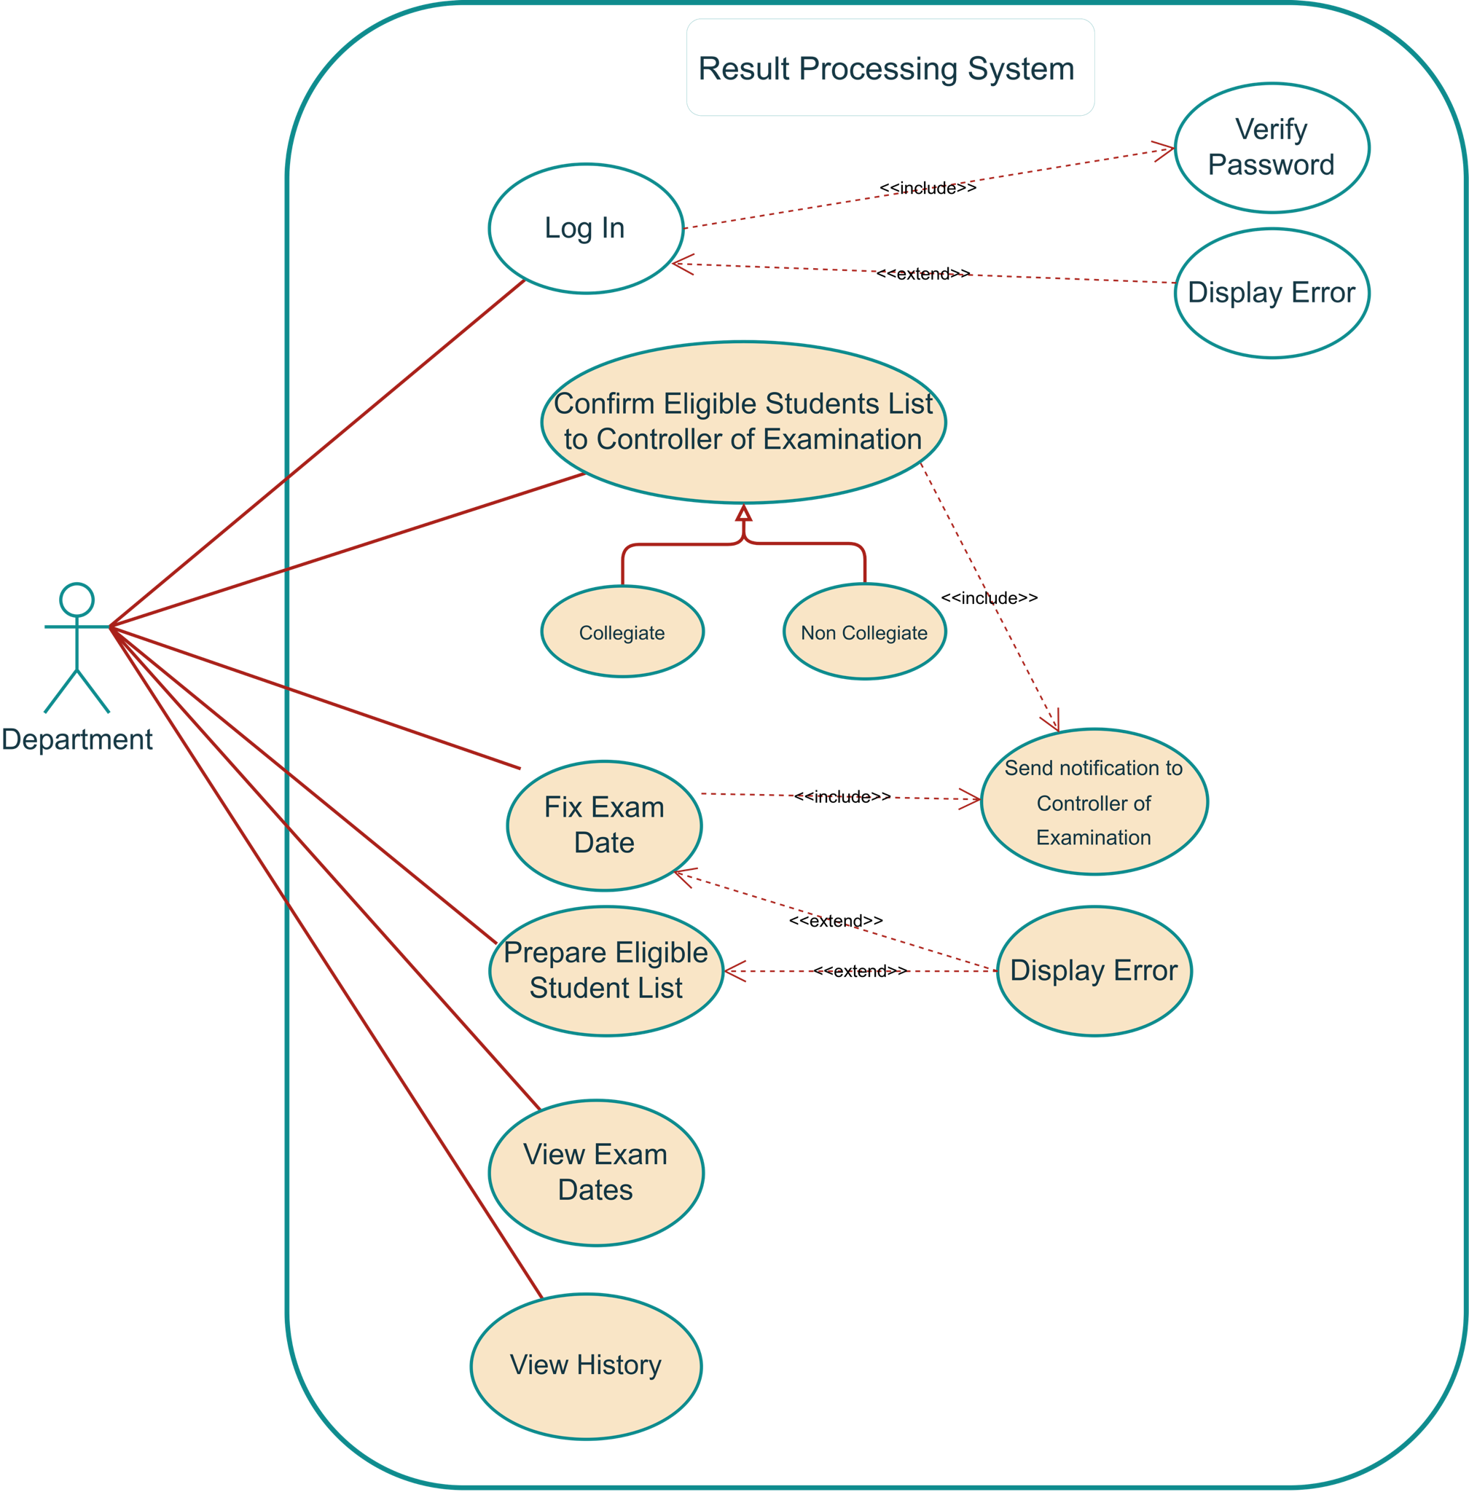

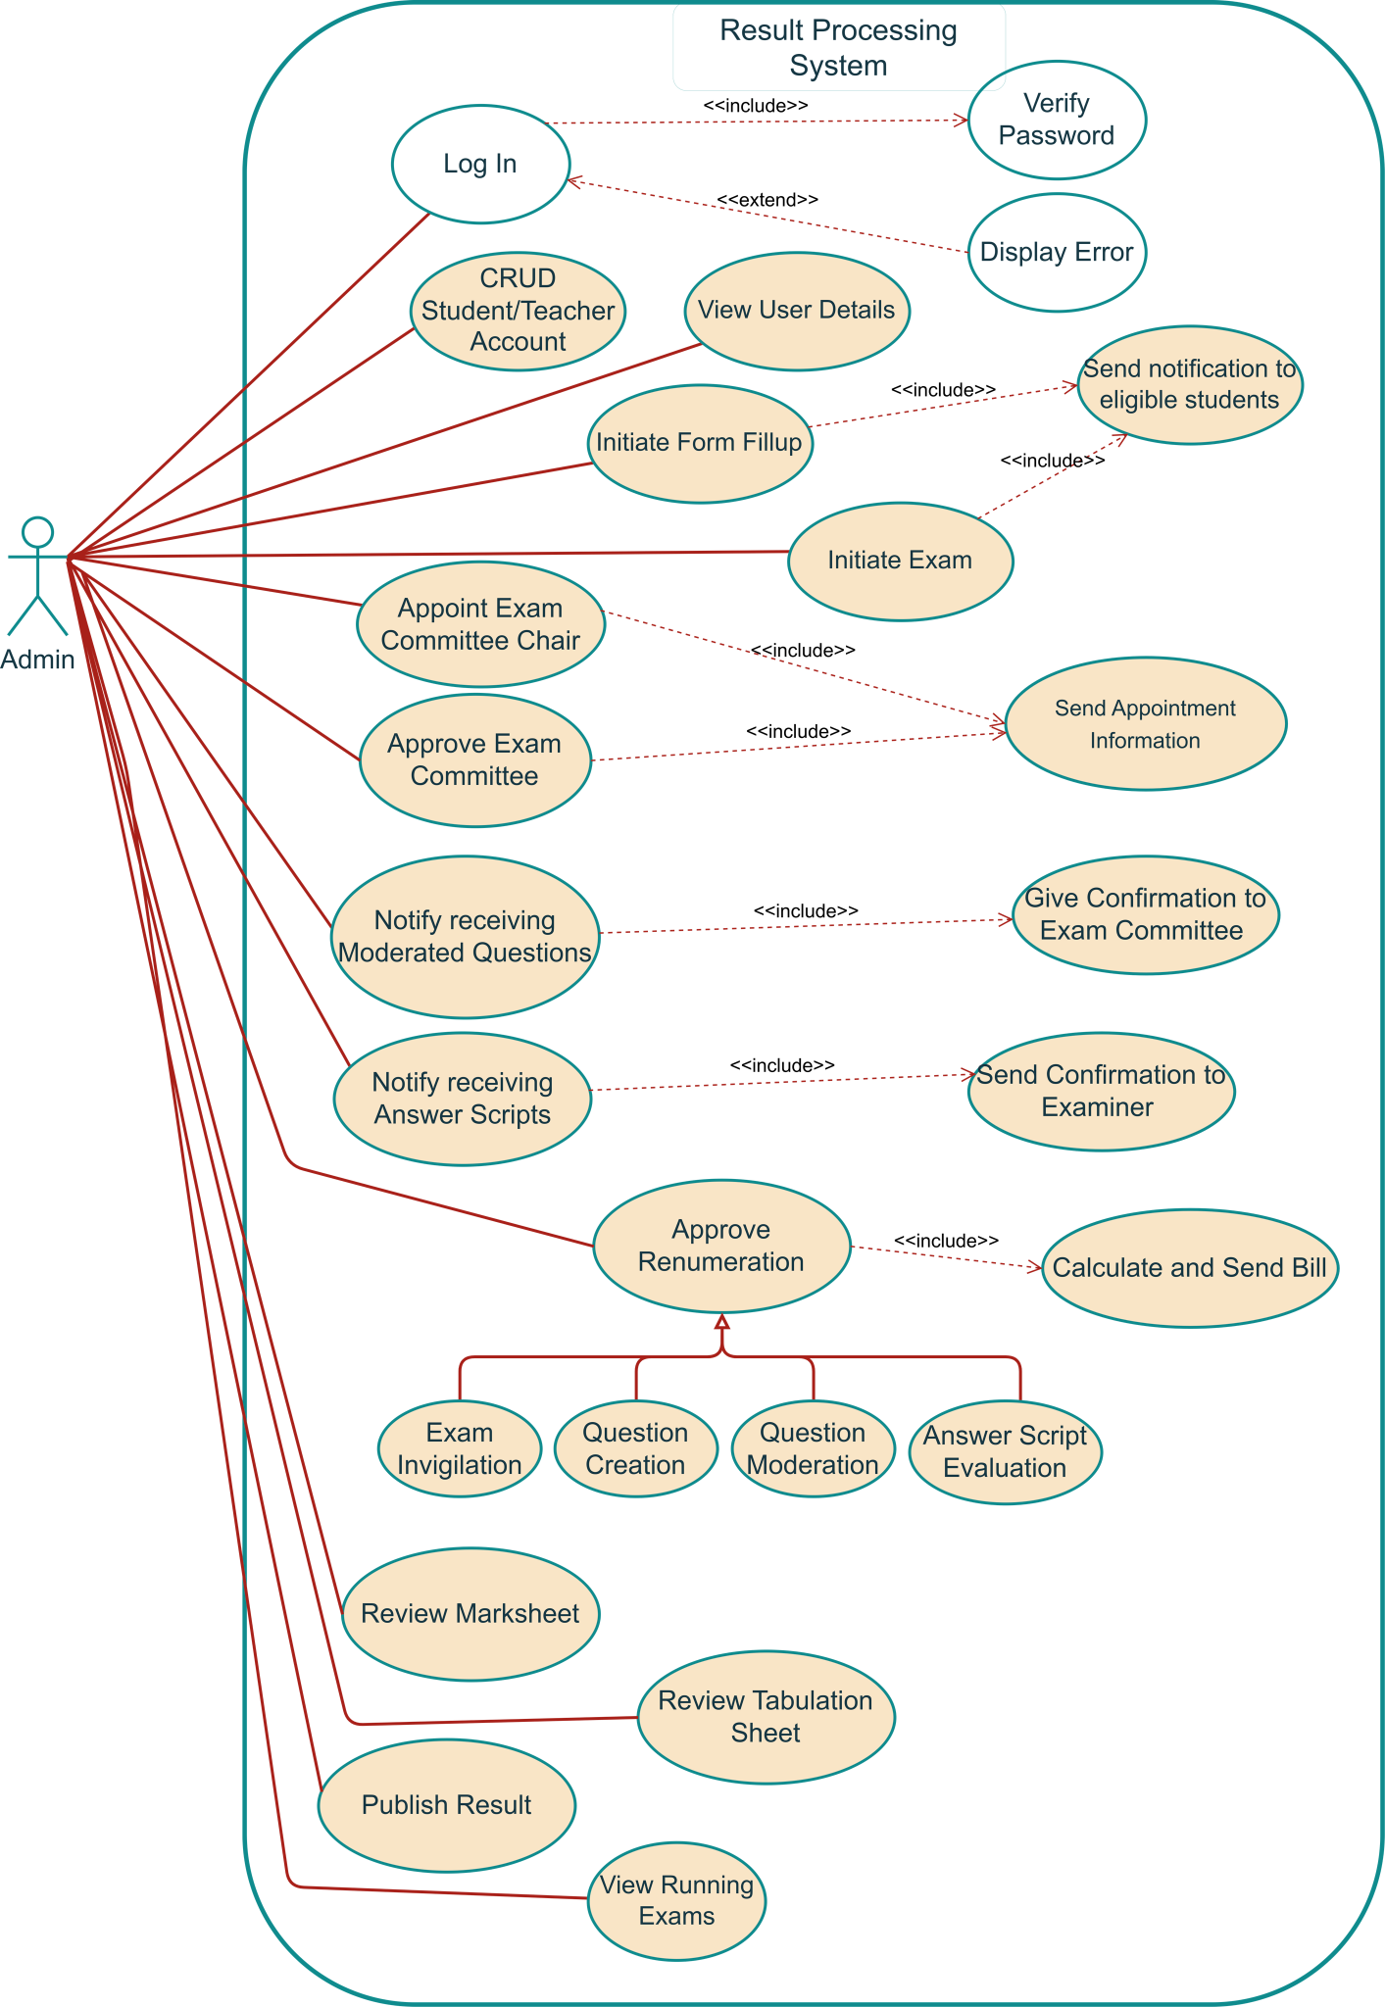

**2.2 sequence diagram (uml)**

**3.** [**Functional Requirements – Scopes & Use Cases**](https://docs.google.com/document/d/18ozbwUCaBnUTzfUSOrGjdkbPeiqtM7Xr/edit#heading=h.17dp8vu)

3.1 Manage Defining Exam Committee Information

| 1 | Scope ID | : | **sc/1** |
| --- | --- | --- | --- |
| General Description of Scope: | | | |
| An examination committee will be prepared for each semester or year of an academic session. The examination committee will decide all examination related decisions such as exam schedule, set the question, evaluate the exam sheet, and prepare the tabulation sheet, teacher bills approval.  Before the examination, an examination committee is formed. The Exam Committee forms for examination consists of 5 members where 4 members are internal and one member is external. Chairman of this committee is the head or highest authority for the exam committee.  Exam Committee information managed by this scope. | | | |

3.1.1 Use cases

#### Add New Exam committee information

| Use Case ID: | **sc/1-1** |
| --- | --- |
| Use Case Description: | This use case describes the flows of storing exam committee information into the system. |
| Actors: | Chairman of the Department, Exam Controller |
| Preconditions: | 1. Chairman of the Department must be authorized user. Chairman of the Department must be logged into the system. 2. Chairman of the Department must have "Add New" access privilege on exam committee information. 3. Derived information must be available in the system. |
| Post conditions: | 1. System will store the information with generating a confirmation message. |
| Normal Flows: | 1. Chairman of the Department: Initiates to add new exam committee information. 2. System: Will show exam committee entry page to add exam committee information. 3. Chairman of the Department: Will enter exam committee and other related information and click on save button for saving required information. 4. System: 5. Will save the information 6. Otherwise will generate alert message when    1. Chairman of the Department is failed to input mandatory information.    2. Chairman of the Department enters duplicate information |

* CRUD Exam committee information

**4. ER Diagram**

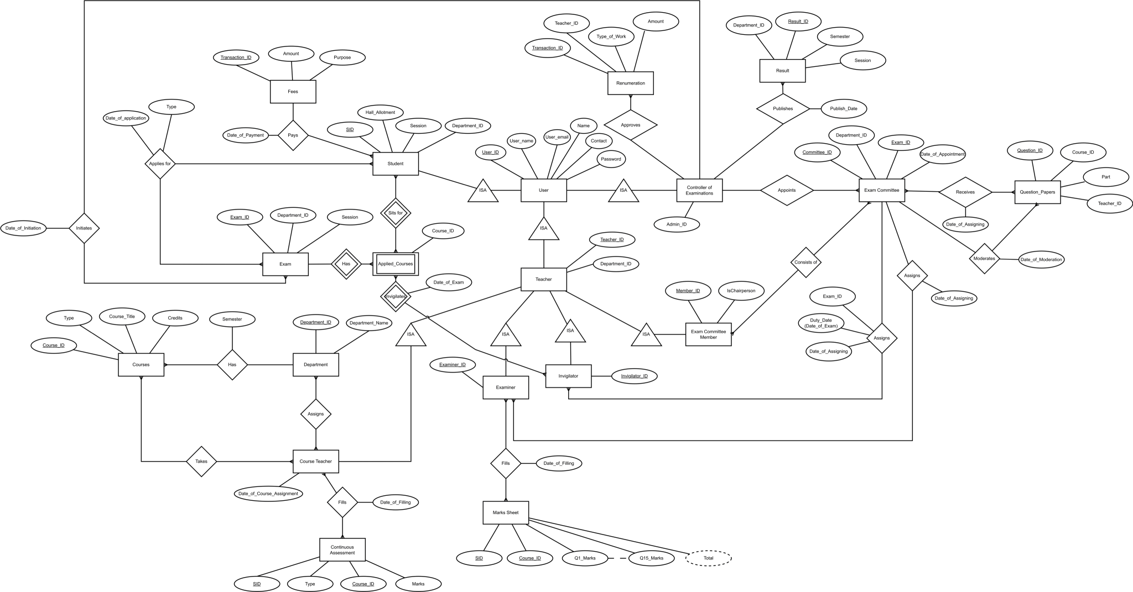

**5.** [**Non-Functional Requirements**](https://docs.google.com/document/d/18ozbwUCaBnUTzfUSOrGjdkbPeiqtM7Xr/edit#heading=h.2fk6b3p)

* System Message

| **#** | **Item** | **Message** |
| --- | --- | --- |
|  | **Successful Add Update** | Information has been saved successfully. |
|  | **Unsuccessful Add Update** | Cannot save the information. Please try again. |
|  | **Successful Delete** | Information has been deleted successfully. |
|  | **Unsuccessful Delete** | Information can not be deleted due to dependency. |
|  | **Blank Mandatory Field** | Please provide the following information |
|  | **Server Error** | Cannot perform the operation. |

* The system must ensure that the data stored in the server must be encrypted.
* The system must be reliable with an uptime of almost 100%.
* The system should be fast and responsive.
* The server should be capable of handling high levels of data and load.
* The system must be simple to use and navigate, enabling users to  
  complete their duties quickly.
* There should be a high performance backup server.
* No user can access data beyond their permission.

**6.** [**System requirements**](https://docs.google.com/document/d/18ozbwUCaBnUTzfUSOrGjdkbPeiqtM7Xr/edit#heading=h.319y80a)

**6.1** [**Hardware**](https://docs.google.com/document/d/18ozbwUCaBnUTzfUSOrGjdkbPeiqtM7Xr/edit#heading=h.14ykbeg)

**Minimum Requirements for client PC:**

| **SL.** | **Description** | **Specification** |
| --- | --- | --- |
| 1 | Processor | Intel Pentium Dual Core 2.6Ghz E5300 |
| 2 | MotherBoard | Gigabyte Intel G31 Chipset G41M-Es2L |
| 3 | Hard Disk Drive | Samsung 160 Gb Sata |
| 4 | Sound Card | On board 8 Channel |
| 5 | LAN | On-board 10/100 MBPS |
| 6 | RAM | 1 GB DDR 800 bus |
| 7 | Mouse | A4 Tech Optical |
| 8 | Keyboard | Keyboard Kbs-720 |
| 9 | Monitor | Samsung 17 Inch Wide Lcd Monitor |
| 10 | Casing | Delux 432 ATX Casing |

## 

**6.2 Software**

**Minimum Requirements of Client side:**

| **SL.** | **Type of Software** | **Software Description** | **Version** |
| --- | --- | --- | --- |
|  | Operating System (OS) | Windows XP Professional/ Windows Vista / Windows 7 |  |
|  | Browser | Internet explorer (IE)  Mozilla Firefox  Safari  Google Chrome  Opera | 8+  3.6+  5.0+ |
|  | Others | Microsoft Office | 2007 |